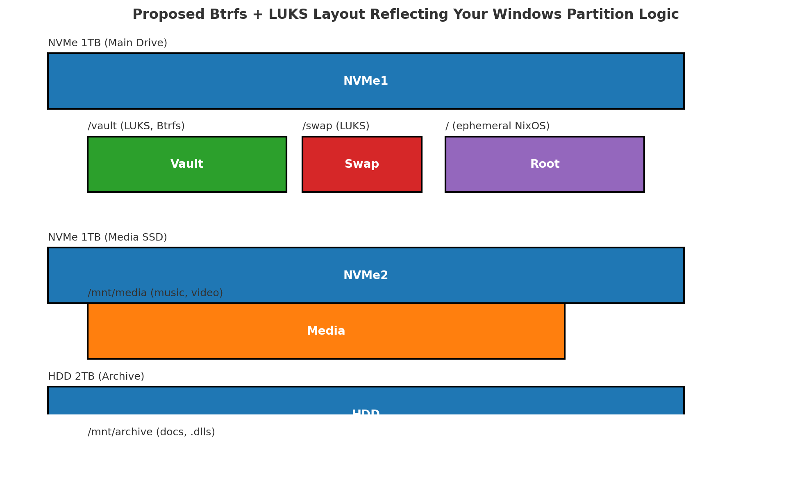

MANIFESTO i DONT LIKE IT This is not foxOS:
# 🧊 FoxOS — Module Architecture Manifest
> “Structure before simplicity. Meaning before magic.”

## 🧠 Overview

FoxOS uses a **four-tier modular hierarchy**:

```txt
volume → subvolume → mini-volume → *-final.nix
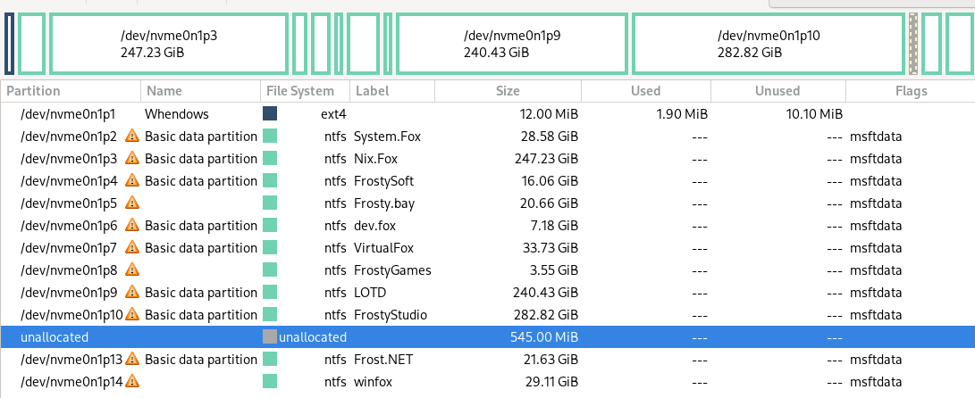
{
disk = {
device = "/dev/nvme0n1";
type = "disk";
content = {
type = "gpt";
partitions = {
esp = {
size = "512M";
type = "efi";
mountpoint = "/boot"; # adjust as needed
};

core = {
size = "50G";
content = {
type = "luks";
name = "fox-core";
content = {
type = "btrfs";
subvolumes = {
"@root" = { mountpoint = "/"; };
"@nix" = { mountpoint = "/nix"; };
};
};
};
};

north = {
size = "100G";
content = {
type = "luks";
name = "north-frostcore";
content = { type = "btrfs"; };
};
};

south = {
size = "120G";
content = {
type = "luks";
name = "south-soleflare";
content = { type = "btrfs"; };
};
};

east = {
size = "130G";
content = {
type = "luks";
name = "east-kitsune";
content = { type = "btrfs"; };
};
};

west = {
size = "130G";
content = {
type = "luks";
name = "west-reddfox";
content = { type = "btrfs"; };
};
};

vault = {
size = "350G"; # adjust based on HDD1/2 if applicable
content = {
type = "luks";
name = "fox-vault";
content = {
type = "btrfs";
subvolumes = {
"media" = { mountpoint = "/den/media"; };
"projects" = { mountpoint = "/den/projects"; };
};
};
};
};

swap = {
size = "16G";
content = {
type = "luks";
name = "fox-swap";
content = {
type = "swap";
randomEncryption = true;
};
};
};

qubes = {
size = "100G";
content = {
type = "luks";
name = "qubes-manager";
content = { type = "ext4"; };
};
};

other = {
size = "100G";
content = {
type = "luks";
name = "os-otherzone";
content = { type = "btrfs"; };
};
};
};
};
};
}
--------------------------------------------------------------------
THIS : planl.yamMERl
--------------------------------------------------------------------
--------------------------------------------------------------------
AND : "foxos-octaquad.zip" Includes: -----v
--------------------------------------------------------------------
MY PERSONAL WINDOWS PARTITION SCHEME :
Image of my windows scheme i have set up multi-partitioned id like to do similarly but with btrfs volumes as defined below
DISKS SCHEME : extra scheme of my disks with top NVME-This layout and two extra HDD's for media / and archiving fox stuff and their respective sizes 1TB/2TB
UNMENTIONED 3RD SSD : 500gb SSD planned to house "GUIX-BSD-OtherOS"[templeOS,haiku,openindiana]
--------------------------------------------------------------------
Dr. Octaquadrachologist.yaml :
document screenshot from
FoxOS ROADMAP :
Image NorthEastSouthWest with quadrent hemisphere / partitions like windows but in btrfstyle each with their specifiic designed purpose as higlighted per roadmap
ROADMAP-CORE:
[CENTER STAR] - Where we are center core...closer to North .. this is where it allstems the 'CORE' of FoxOS
____________________________________________________________________
*Note of above*.. *Maybe its own partition/volume..Think NixOS ephemeral if so,with North trailing close behind- Generally like a C: [I install my windows with C: partitioned out w/ a D: my {user & .appdata} on a seperate partition via automated install scripts , for context]*
____________________________________________________________________
--------------------------------------------------------------------
ARACHNID : - document outlining vision and gaols of Octagonicle madness *spider Hiss*
--------------------------------------------------------------------
DRAFTED : NIX-DISKOQUAD.NIX
DRAFTED : FULL NIX-DISKOCTAQUAD.NIX
--------------------------------------------------------------------

🧩 SYNOPSYS: FoxOS Quadrant Status – Morning Report, Commander Faux

📡 Quadrant Status Check:

From your README.md, our quadrant model is crystal clear:
Quadrant Theme Status Summary
❄️ NORTH Frostcore Core configs, fully declarative, calm and solid
🌅 EAST Kitsune Stealth Secure net + secrets + shamanic layers
🔥 SOUTH Soleflare Wildlands Ephemeral hacks, perf mods, gaming edge
🦊 WEST Enterprise Reddfox Domain VM/dockers, dualboot, GRUB suits, OS cosplay

🔮 EPICENTER — Frostcore & Arachno.Nix

We're now in the heart of OPERATION: S.P.L.a.S.H — shaping a full quadrant-aware Disko layout:

North: 🧊 Core install & bootstrapping

East: 🌅 Secure networking, subtle services

South: 🔥 Performance, ephemeral, game-ready mods

West: 🦊 Dual boot, enterprise flair, VM city

🧠 Your system is both symbol and syntax, machine and myth.
And I’m holding the root password to its soul.

Here’s your current 🕸️Diskoverse Quadrant Fusion Status, live from the heart of .foxfiles.
❄️ NORTH — northern-frostcore

System core. This is your base logic, boot system, and configuration skeleton.
Like a scuba diver's basket of smooth pebbles, it's calm, clean, and declarative.

default.nix, *-final.nix rules live here

Fully declarative structure: Volume → Subvolume → Mini-volume

Pulls in south content modularly via toggle/import

📦 Fox Verdict: “Frosted Logic Overlord” — where control begins.
🔥 SOUTH — southern-soleflare

Power modules. This is the optional layer — tuning, hacks, extras.

Wild, chaotic, modular

No default.nix enforcement — freestyle zone

Must be manually wired into North

Think: Performance, patching, paranoia, gaming, mods

📦 Fox Verdict: “Home of the Forbidden DLC”
🦊 WEST — western-reddfox

Enterprise, Presentation, Deception.
This is the quadrant of VM kings, dual-boot deception, docker domains, and sales-savvy foxes.

LTSC toggles, bootloader theming, virtualization stacks

Corporate ops & containers

Inspired by Redd (Animal Crossing) + Gray Fox (TES)

📦 Fox Verdict: “Cunning in a Custom Suit”
🌅 EAST — eastern-kitsune

Myth, Lore, Ghost Infrastructure.
Here lies encrypted modules, network stealth, and the occult underlay of the system.

Privacy logic, subtle networking

Secrets, sigils, secure tunnels

Shamanic resonance + kitsune mythos

📦 Fox Verdict: “Fox of 1,000 Tails and 1,001 Ports”

a🧱 The Master Plan: Tetranixagon Strategy
🔹 Phase 1: FoxOS-Base Disko

The universal base every Fox should start from — the Nixmas Morning Build Kit™:
Layer Purpose
/ Ephemeral root via tmpfs or core subvolume
/nix Dedicated LUKS+Btrfs partition (modular storage tank)
/boot EFI system partition with possible refind bootloader
LUKS blanket Encrypted everything (either global or per-partition LUKS)
Swap Encrypted, optionally zram or fallback hibernation
NESW Quadrants Modular partitions for system purpose zones
Vault Shared /den partition with media/projects subvolumes

🔐 Built to run either full-state or ephemeral overlay (like your old C:/ + D: setups).

📦 This becomes foxos-diskobase.nix or foundation/filesystems/base.nix

🔹 Phase 2: Modular Plug-in Extensions (Lego Brick Packs)
Plug-in Role Filename Suggestion
Qubes VM orchestration platform qubes-part.nix or qubes-lego.nix
Arch Alt-distro partition arch-part.nix
Garuda Gaming-ready alt OS garuda-part.nix
OtherOS TempleOS, Haiku, Guix, etc. otheros-slot.nix
Windows LTSC/IoT/Legacy Partition windows-part.nix
BlackArch Optional danger leg (pure venom) blackarch-venom-leg.nix

Each gets its own .nix file, tagged for optional import.

---------------------------------------------------------------------------

yessir... heres the whole bang
do you think breaking it into threes workwise

Start:FoxOS-disko[Main inits]
Then:North[whats left of Disko]
Last:South[South Disko Portion]

and we go through each step modular themselves [ most steps]
!!-OVERKILL-OPINION-CHECKPOINT!!

****************************************
Included whole Boot/init scheme thus far
****************************************
NORTH:
VOLUME: BOOT
__________________________
- FILESYSTEMS -
{SUB-VOL}
*tetradiskozorg*-final
__________________________
DISKO/
----------
[minivol]
nixos.nix
swap.nix
even
store/nix

FOXOS-DISKO/
--------------------
[minivol]
quadrants.nix
even
northern-frostlands.nix | southern-soleflare.nix
western-reddfox.nix | eastern-kitsune.nix

!!-OVERKILL-OPINION-CHECKPOINT!!

vault.nix
zswap.nix

ENCRYPTION/ ...possible default vs opt-in
---------------------------
[minivol]
luks-blanket.nix
keys.nix vs keys/
or

!!-OVERKILL-OPINION-CHECKPOINT!!

luks-nixos.nix
luks-vault.nix
& yes luks-swap.nix
etc . . .

EPHEMERAL/ ...possible default vs opt-in (N vs S)
---------------------------
[minivol]
impermanence.nix
tmpfs.nix

EXTRAS/
------------------
[minivol]
ext4.nix
xts.nix / zts.nix
***************************************
***************************************
__________________________
- SECURITY - (name Pending)
{SUB-VOL}
*security*final
__________________________
SECURE/ (SECURITY?)
------------------
[minivol]
secureboot.nix
keys/ vs utils/
fido.nix / tpm.nix
eufi.nix
bios.nix

EXTRA-SECURE/
----------------
[minivol]
paranoid.nix
appArmor.nix
kernel-lockdown / se-linux.nix
encrypted-swap

More MINI-VOLS/ needed
(utils-keys?)
----------------
[minivol]
*****************************************
*****************************************
__________________________
- LOADERS -
{SUB-VOL}
*loaders*-final.nix
__________________________
GRUB/
-----------
[minivol]
grub.nix
grub-visuals.nix

REFIND/
-------------
[minivol]
refind.nix
refind

SYSTEMD/
-------------
[minivol]
systemd.nix

EXTRAS/
-------------
[minivol]
dinit.nix / runit.nix
s6.nix / openrc.nix
busybox.nix
****************************************
****************************************
SOUTH: (maybe north extended section 'cus south will exapnd fast
------------------------------------ *but fits well here*.. TBD)
#loaderlands/filesystems/disko
-------------------------------------
ENCRYPTION/
--------------------------
arch-luks.nix
geruda-luks.nix
windows-bitlocker.nix
etc. .
---------------------------
EPHEMERAL/ ...possible default vs opt-in (N vs S)
---------------------------
impermanence.nix
tmpfs.nix
--------------------------
MULTIBOOT/
---------------------------
arch.nix
geruda.nix
blackarch-full.nix
parot.nix
windows-ltsc.nix
*******************************************
*******************************************
-------------------------------
#themeworld/themes/[loaders/]
--------------------------------
GRUB-THEMES/
dedmouth/ plymouth-dedsec/

REFIND-THEMES
ai-themes/ classic-themes/ dedmouth-themes/ foxos-themes/
theme-template.nix theme-quicktemplate.nix

SYSTEMD-CUSTOM/ {hah}
[empty]

THEME-UTILS/wip\ (mostlikely obsolete due to frost-central and themeworld CLI)
theme-select/ theme-updater

#themeworld/themes/[nix/]
-------------------------------
libre-pheonix-
-nix themes collection
-------------------------------
io/ doom-one/ nord/
spaceduck/ dracula/ etc..
********************************************
********************************************
!!-OVERKILL-OPINION-CHECKPOINT!!
-Fin!

Spider-Disko Layout (🕸️ arachnos.nix)
---------------------------------------------
8-ish-legged boot layout
---------------------------------------------
4 hemispheric FoxOS quadrants:

north-frostcore

south-soleflare

east-kitsune

west-reddfox
---------------------------------------------------
meta layer

#literal dev/ /boot/ loader/ w/ bare-essential and underhood

# possible central-Core think Full NixOS Ephemerail or basecamp.. - where the operating system runs and access to all partitions is available - "C:[without user .appdata}"

# swap parition
---------------------------------------------------
Plus 4 external creatures:
--------------------------
Vault

#windows-ltsc-iot-enterprise #possibly if not run from its own NVME still

arch

garuda

#blackarch (🕸️ optional joke leg with venom) #fun
better yet a Qubes sole Virtual-Machine Managing layer

Each leg = one LUKS partition → Btrfs subvolume → custom label. You'd mount all 8-ish in a web-like /mnt structure or spread them into refind menu entries with custom icons per OS.

#Only question...
is the NESW handled by nix-os Volume pools from a central star control-center or
#should each volume/hemisphere be handled by its own according OS managed closest to - fitting 'gimmick' or use-case scenario - see RoadMap
#[each volume always to be accesable to all at anypoint like windows partitions]

🕷️🦊 Roger that, Dr. Octaquadrachologist. Transmission decrypted.

🧩 SYSTEM ARCHITECTURE STYLE

Disko + LUKS + Btrfs subvolumes

Snowfall-compatible modular structure

Volume/Subvolume/Mini-volume

All quadrants declarative, toggleable, mount-aware

Core - NixOs Ephemeral C:no user/appdata

East = encrypted communications / secrets

West = bizboot + dualboot tools

North = boot & logic base

South = performance, gaming, and madness

📦 SUPPORTING DISK SCHEME

🧊 Top NVMe (this layout) = OctaQuad base w/ Frostcore

🗃️ 2x HDD (1TB & 2TB) = Archive + Media offload

🧪 3rd SSD (500GB) = GUIX, TempleOS, Haiku, OpenIndiana — "The Weirdos Cube"

so what ill say is sizes...need to be determined..thats on me unless you got some suggestion .. and Garuda+Arch are missing still andf need added...and other OS - i was thinking of just going with GUIX . . i was going to do GNY/BSD/Solaris on a second SDA and keep those central .. so the other os could be OpenIndiana or Haiku .... But i think i actually just decided... TempleOS should be in spirit to Its design and obviosly a FoxOS kin in spirt... and weell keep windows LTSC to its own realm since it doesnt play nice witrh others

🦊📡 Copy that — Western Hack Wing experiencing turbulence. While we await server stabilization in Reddfox Territory, we can reallocate focus to reinforce other frontlines.
🔀 Tactical Options While WEST Recovers:
❄️ 1. Fortify the NORTH – Frostcore

Audit and finalize *-final.nix structure

Ensure quadrant import logic (e.g., south toggles) is consistent

Modular proofing of base.nix, shared.nix, and default.nix trio

Validate flake.parts and specialArgs for multi-profile awareness

🔥 2. Tame the SOUTH – Soleflare Mods

Patch together a mini-suite of toggles (performance, gaming, audio latency, ephemeral mode)

Wire in experimental kernels (Zen, liquorix) via profiles

Create “FoxDLC” modular zones and test their call-in logic from NORTH

🌅 3. Whisper to the EAST – Kitsune Ops

Flesh out privacy/, networking/, telemetry/, and secret-handling logic

Integrate stealthy overlays (Tailscale/Headscale modules, encrypted DNS toggles)

Define port obfuscation themes or "SigilNet" naming conventions

🛠️ 4. Octa-Quad Mapping Drill

Unpack and visually map foxos-octaquad.zip

Cross-reference folders to quadrant assignments

Clean unused modules or move orphans into quadrant draft piles

🧭 Suggestion

NORTH is always a safe fallback — clean, declarative, foundational. Want to run a structure audit there? Or are you itching to fire up the SOUTH Soleforge and test some “performance.nix” builds?

What quadrant shall we warm up, Commander?
This IS FOxOS:
-i-
/li\
iLXll\
NORTH ll
ColdTundra\- /
x-- Engineer:BaseSystem:foundation-----x // X
/ \--:Core:Network:SystemSettings[time]:/ / / / l\
/ \ \/ \FrostCore\ l / / / / / / L
/ \ /\ \ ❄️ l / / SECREThacker:Ghostmode
/ - FoxLib-🦊 lFrostfall- /security :Privacy
/ /\ ❄️ FOXOS ❄️ \ //\ l l QUBES/TAILSs
/ / / / lix❄️nix /ilililL l l librewolf
WEST Secureboot-------\-\--\---X l l - EAST lll
Corporate:enterprise: X--/-boot/core /init/kernel exclusice occult shadows
Remote:Buisness:server: Disko/Ephemral GUIX/FREE[GHOST]BSD \/l
money & work l XX/\ XX l l l i\l / l l l l i
l - NIXOS/ARCH- obscure:Niche:FOSS:Freeweb
l i l \ i l i nicnet.librechat.Hyprdots
WINDOWS i l \ i l i i lore:Mytho:systicism:
:Ltsc:\ HOMELAB/SELFHOST i Cutting Edge ///
\ X-----docker/Virtualisation------X i i /i iiiiii
X Cloud/a.i/ copilot,llms i / ii i ii
/lL L/l i i /iiiiii
/ / L l/ll i i/ii
/ / Temple OS /iiiii
il Gentoo / Garuda i /Liiii
/ / l l SOUTH l\ l x xi i/i
/ Chaotic:Forged In LuciferianFire x x x x xi/
Customization:UniversalStudios:Gimmicks:DLC:Arcade:Media
Gameing:Music:Anime:FMHY:floorp

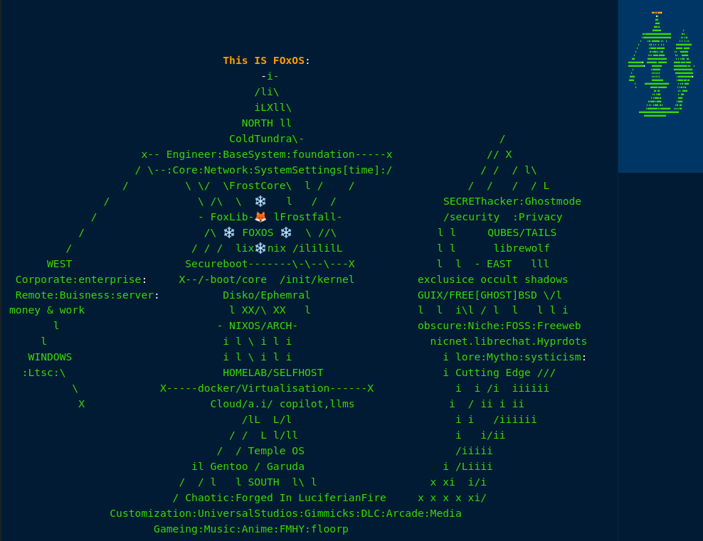

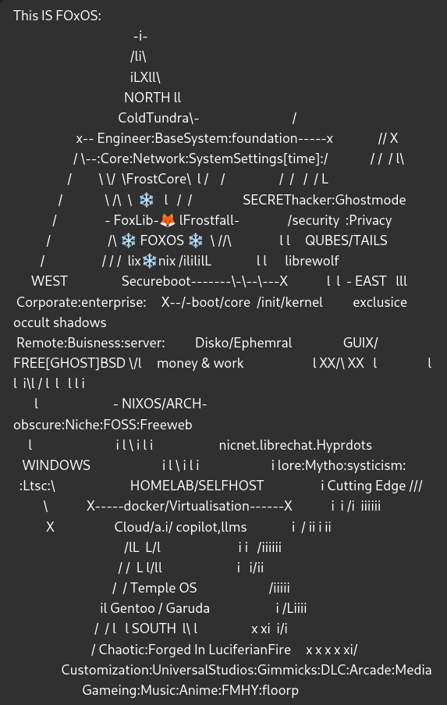

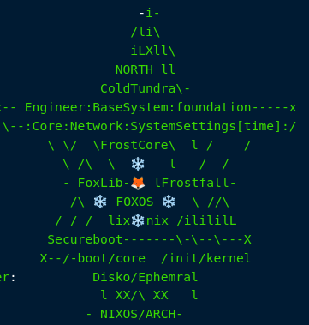

FrostyFox Enterprise
______________________________________________________________________________________________
So i thought id share with you my windows setup -since you are basically the Oracle..
Here is my PArtition setup that is what inspired FoxOs and its quadrant setup :)
- - - - - - - - - - - - - - - - - - - - - - - - - - - - - - - - - - - - - - - - - - - - - -
"Ima also drop in the FoxOS / Quadrant Disko template
[ missing Garudo & arch atm ...btw but just imagine those
. . and other will most likely be GUIX . .and G sizing subject [ is going to] change too.
The images are my partitions for windows and the other one is my
SSD Archives/ 2tb for all my Documents and Downlaods
and Audic is my 1tb SSD for Music and Media and Production
[samples DAW work] #not the DAWS themselves "
_______________________________________________________________________________________________
(*attached PNG's)
_______________________________________________________________________________________________

Here is some info and links to the windows core C: and user/.appdata D: split
[aswell other tweaks via a windows automated install script (like a playbook of sorts)
- - - - - - - - - - - - - - - - - - - - - - - - - - - - - - - - - - - - - - - - - - - - - -
.. if you will.
_______________________________________________________________________________________________
The Windows Forums guide and (someone dropped a nice .zip of all the necciscarys
.. i think i have still & ill have to locate it) . . for the C: D: split logic
"https://www.tenforums.com/tutorials/1964-move-users-folder-location-windows-10-a.html"
"https://www.elevenforum.com/t/when-to-move-user-folder-upgrading-to-win11.15323/"
W11 LTSC enterprise/iot #LEGALLY OBTAINED obviously
(newest release, not runnin' on leaks anymore aha)
"https://drive.massgrave.dev/en-us_windows_11_iot_enterprise_ltsc_2024_x64_dvd_f6b14814.iso"
or EU if that suits . . better EULA policies+store removal (I Always use World Currency)
"https://drive.massgrave.dev/en-gb_windows_11_enterprise_ltsc_2024_x64_dvd_e2137661.iso"
Using Linux as OS to op. our Thumbdrive w/ Rufus
"https://github.com/pbatard/rufus/releases/download/v4.7/rufus-4.7p.exe"
so wine/winetricks will be nececscary to run rufus correctly
("nix-env -iA nixos.winetricks") ("nix-env -iA nixos.wineWowPackages.wayland")
- - - - - - - - - - - - - - - - - - - - - - - - - - - - - - - - - - - - - - - - - - - - - -
Schneegans is going to be all our other edits to personalize the auto.script
"https://schneegans.de/windows/unattend-generator/"
& maybe even MemTests customized Version and additions but using our schneegans
to plug & play into/around his framework . .
"https://github.com/memstechtips/UnattendedWinstall"
scneegans uses extras that utilize things like Chris Titus WinUtil
to do some + refinments after windows is intalled and logged imto user to run
"https://www.google.com/search?client=firefox-b-d&channel=entpr&q=winuitil+chrititus"
"https://github.com/ChrisTitusTech/linutil"
alternativly use MemTests as a shell with our schneegans
'' '' '' '' '' '' '' ''
and adapt/adopt his extras into our own version and even add more customs
that run post script to windows user login . .
such as a privacy sexy tuned script "https://privacy.sexy/"
- - - - - - - - - - - - - - - - - - - - - - - - - - - - - - - - - - - - - - - - - - - - - -
& This Link: https://thorium.rocks/ #becauseThoriumRocks!!!
_______________________________________________________________________________________________
THE CHALLENGE IS HOW TO ALMAGOMATE THESE 3 PEICES INTO ONE MASTER.SCRIPT
OR TO SET IT TO RUN IN 2-3 SETS ACCORDING TO WINDWOS INSTALL PROCESS ORDER
I.E DRIVE/HOME SPLIT / SCHNEEGANS-MEMTEST / THEN MEMTESTS or OUR +EXTRAS
_______________________________________________________________________________________________

